Ken Rivard

Assignment 5 Part 1

CS 3310 – Dr. Ajay Gupta

10am Section

TA: Yu Guo

Due Date: November 28th, 2016

1. **Derive the relationships among height *h*, total number of nodes *n*, number of leaves *L*, and the number of edges *m* in a complete quad tree *T*. In particular, given *h*, what is *n*? Given *n*, what is *h*? Given *m*, what is *h*? Given *L*, what is *h*? Given *h*, what is *L*?**
   1. Given h, what is n?
      * Each quad-tree is split into 4 nodes at each leaf so at any level h, there are 2h by 2h nodes in the level which is also equal to 4h. So given the height, we can find the number of nodes using the formula **n = 4h+1 - 1.**
   2. Given n, what is h? (NOTE...log is base 2 in computer science)
      * N = 4h+1-1
      * n + 1 = 4h+1
      * log(n+1) = log(4h+1)
      * log(n+1) = (h+1)log4
      * log(n+1) = 2(h + 1)
      * **h = log2(n + 1) - 1**
   3. Given m, what is h?
      * From the below equation …
      * **h = m – 4 leaves**
        + since each node will have 4 children
   4. Given m, what is n?
      * Assuming T is a complete quad tree …
      * height = h
      * edges = m
      * in a complete quad-tree **m = h + 4 leaves**
        + since each node will have 4 children
   5. Given L, what is h?
      * X = Σ0..L 4n = (4L+1 – 1) / 3
      * L = log4L
      * **X = (4 * L – 1) / 3**
   6. Given h, what is L?
      * From the above equation we can derive …
      * **L = (3/4)x + 1**

**2. Repeat question 1 if *T* is a full quad-tree**

**Here is my work for a Full Quad Tree Representation**

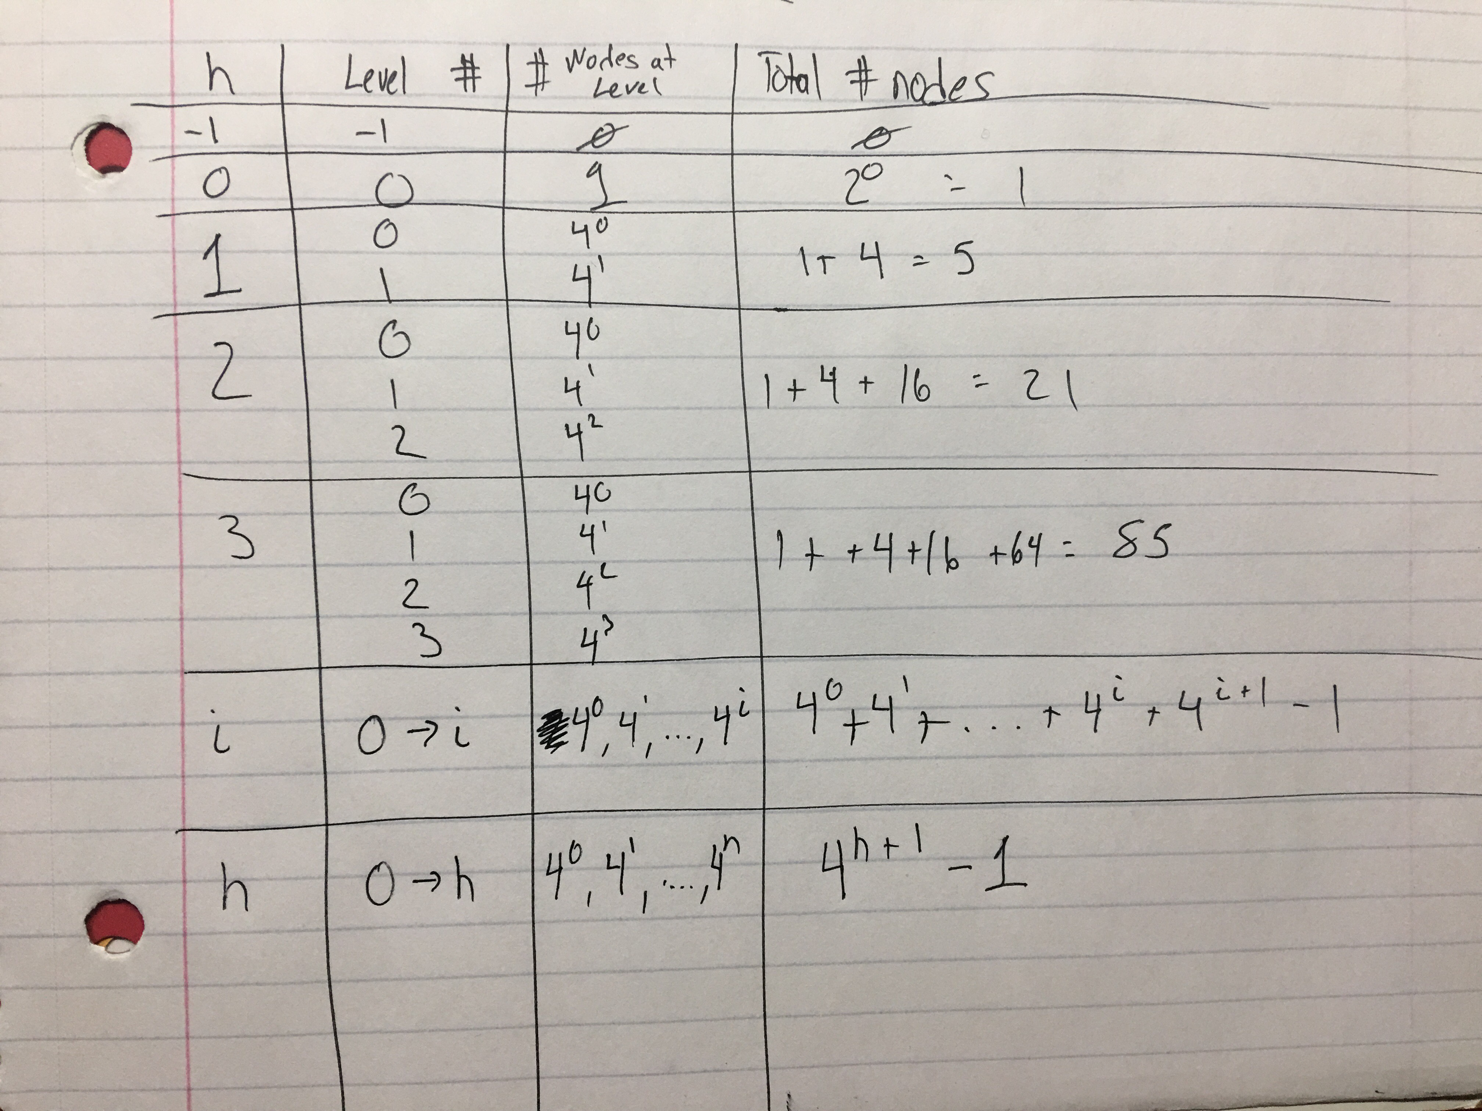

Given h, what is n?

* + - **N = 4h - 1**
  1. Given n, what is h?
     + N = 4h+1-1
     + n + 1 = 4h+1
     + log(n+1) = log(4h)
     + log(n+1) = (h)log4
     + log(n+1) = 2(h)
     + **h = log(2*(n + 1)) - 1**
  2. Given m, what is h?
     + From the below equation …
     + **h = m – 4 leaves**
       - since each node will have 4 children
  3. Given m, what is n?
     + Assuming T is a complete quad tree …
     + height = h
     + edges = m
     + in a complete quad-tree **m = h + 4 leaves**
       - since each node will have 4 children
  4. Given L, what is h?
     + From the equation below we can derive …
     + log(L + 4) – 1 = log4(h+1)
     + log(L + 4) – 1 = 2log(2 * h + 1)
     + h = ( (log(L + 4) ) / (2log(2) – 1) )
     + **h = (log(L + 4) / (2log(2)) - 2)**
  5. Given h, what is L?
     + Since each node will have 4 leaves (L) we can take the node count equation N = 4h+1-1 and multiply that by 4.
     + This gives us L **= 4 * ( 4h+1-1)**

**3. Describe an implicit representation of a quad-tree *T* using arrays. Give the declaration of the array that stores the data of the nodes of *T*. Assume that the data consists of three fields, ssid, name, and phoneNumber. Given a node *v* of *T* at index *i*, what are the indices of the four children of *v* and the parent of *v*?**

For each data field, ssid, name, and phoneNumber, a node will be used. An additional 4th node will be used to store the data of the 3 fields. For node ssid, the first node will be the 0th element of the ssid array, for node name,the first node will be the 0th element of the name array, and finally for node phoneNumber, the first node will be the 0th element of the phoneNumber array. The question does not specify how the elements should be added into the array so the order of how the elements are added into the array can vary. In class we added the elements into the array from a left to right order, but we can also traverse through the tree by inorder-traversal, preorder-traversal, or postorder-traversal.

4h <= n <= 4h+1 – 1

node *v* is at index *i*

leftmostChild(v) is at 4i + 1

middleLeftChild(v) is at 4i + 2

middleRightChild(v) is at 4i + 3

rightmostChild(v) is at 4i + 4

parent(v) is at ⌞i-1 / 4⌟

**4. Let *T* be an (unbalanced) binary search tree :**

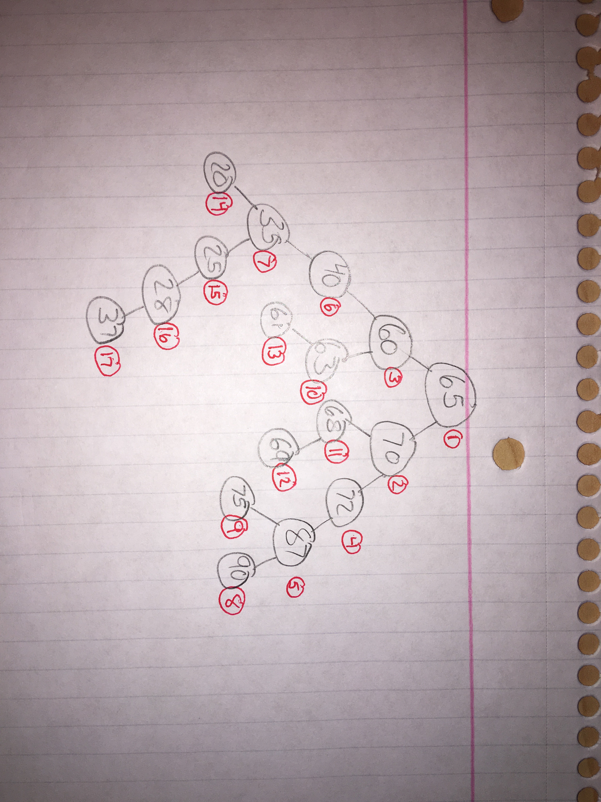a) **Insert the sequence 65, 70, 60, 72, 87, 40, 35, 90, 75, 63, 68, 69, 61, 20, 25, 28, 37**

**(of integer keys) into T. Show the tree after each insert operation.**

The numbers in to the left of each node in red indicate the order in which each integer was inserted into the tree

b) **Show the output of Preorder, Inorder and Postorder traversals of T after last insertion (i.e., after key 37 is inserted).**

* Preorder
  + 65, 60, 40, 35, 20, 25, 28, 37, 63, 61, 70, 68, 69, 72, 87, 75, 90
* Inorder
  + 20, 35, 25, 28, 37, 40, 60, 63, 61, 65, 75, 87, 90, 69, 68, 70, 72
* Postorder
  + 20, 37, 28, 25, 35, 40, 61, 63, 60, 75, 90, 87, 69, 68, 72, 70, 65

**c) Delete the sequence 28, 72, 65, 35, 63, 87, 70 from T. Show T after each deletion.**

**Note that to be consistent in deletion, follow the same algorithm when you have to**

**“borrow” a key to fill a hole.**

